History

Hungarian chemometricians have met every year for three days to see the latest results of their colleagues. Kemometria’01 will be the 22nd in series.
In four cases the Hungarian Chemometric Workshop was included in the general assembly of the Analytical Branch of the Hungarian Chemical Society. Abstracts and programs of past conferences can be found on the Internet:
Conferentia Chemometrica CC'97, Budapest, Aug. 21-23 1997.
http://www.jate.u-szeged.hu/~rajko/CC97.html
Kemometria'98, Miskolc-Lillafüred, Oct. 7-9 1998.
http://www.jate.u-szeged.hu/~rajko/Kemometria98.html
Kemometria'99, Szeged, Oct. 17-19 1999
http://www.jate.u-szeged.hu/~rajko/Kemometria99/

Topics

Quantitative Structure Activity Relationships
Data Analysis, Multivariate Techniques
Experimental Design
Applications, Spectroscopy, Chromatography
Quality Assurance
Teaching of chemometrics

Proceedings

Selected lectures (invited and submitted, oral or poster) will be published in a special volume of the Chemometrics and Intelligent Laboratory Systems (Elsevier) or Journal of Chemometrics (Wiley) after the normal refereeing process.

Lectures and Posters

- T. Cserháti, E. Forgács (IC CRC HAS, Budapest): Principal Component Analysis: Pitfalls and Possibilities
- W. Demuth, K. Varmuza (Vienna University of Technology): Genetic Algorithms in Feature Selection
- G. T. Frumin (NWAFS St.-Petersburg) Biodegradability prediction using Quantitative Structure – Activity Relationships
- I. Gutman (University of Kragujevac): Choosing the Exponent in the Definition of the Connectivity Index
- M. Holík (Masaryk University, Brno), J. Halámek: Confidence Ellipses for the Quantitative Analysis when the Data are Curves
- O. A. Raevsky (IPAC RAS Chernogolovka) Prediction of Molecular Properties for Chemicals and Drugs on the basis of Structural Similarity and Physicochemical Parameters
- D. Amić, B. Lusić, S. Nikolić, N. Trinajstič (Boskovič Institute, Zagreb): Structure-Property-Activity Modeling using Weighted Path Numbers
- K. Varmuza (Vienna University of Technology): Chemometrics for Planned Mass spectrometry Experiments Near a Comet
- K. Varmuza and W. Demuth (Vienna University of Technology): Chemical Structure Similarity in Mass Spectral Similarity Search
- I.G. Zenkevich (St. Petersburg University), P. Kránicz: Non-linear Functions for Approximation of Physicochemical Parameters of Homologues
- I.G. Zenkevich (St. Petersburg University): Prediction of GC Elution Order of Isomers using Molecular Dynamics Calculations
- T. Blenkers, P. Zinn (Ruhr – Universität Bochum) Genetic Algorithm in Structure Elucidation

Excerpts from Hungarian Lectures and Posters

- A. Felinger, M. Káré (University of Veszp-rém): Fourier and Wavelet transformation of Baseline Noise in Chromatography
- Zs. Kánya, E. Forgács, T. Cserháti (IC CRC HAS, Budapest): Reducing Dimensionality in Principal Component Analysis. A Method Comparison
- G. Galbács, I. Horváth, I.B. Gornushkin, B.W. Smith, J.D. Winefordner, Z. Galbács (University of Szeged): A New Calibration Approach using Linear Correlation in Spectroscopy
- K. Héberger, T. Kowalska, M. Görgényi Linear or Nonlinear fit? A Comparison using Temperature Dependence of Kováts Indices
- P. Szepesváry (L. Eötvös University) Recent Progress in Theory of Chemometrics
- A. Lengyel, O. Bánhidi, L. Paksy (University of Miskolc): Principal Component Analysis of Physical and Chemical Features of River Sajó
- I. Raisz, P. Raisz, J. Emmer (University of Miskolc) Critical Evaluation of Cyanide Measuring Methods
- R. Rajkó (University of Szeged): Rank Hunting: Difficulties of Rank-Determination of Matrices and Other Complicated Data Arrays
Lectures of G. Horvai, S. Kemény, I. Kövesdi, T. Pap, etc. are also expected.

Organizing Committee

Chairman: K. Héberger (Institute for Chemistry, Chemical Research Center, Hungarian Academy of Sciences, Budapest)
Secretary: R. Rajkó (University of Szeged)
Members:
Gy. Horvai (Technical University of Budapest)
S. Kemény (Technical University of Budapest)
A. Lengyel (University of Miskolc)
L. Paksy (University of Miskolc)
T. Pap (University of Veszprém, Veszprém)
P. Szepesváry (L. Eötvös University, Budapest)
Local organizers:
chairman: Barna Kovács (University of Pécs)
Gábor Mihalovics (University of Pécs)
Terézia Mihályi (MKE, Budapest)

Conference Secretary: Dr. Róbert Rajkó.
Department of Unit Operations and Environmental Engineering, University of Szeged College Faculty of Food Industry
H-6701 Szeged, POB 433, Hungary
Tel.:+3662-546-030
Fax: +3662-546-034
E-mail: rajko@sol.cc.u-szeged.hu
Financial affairs:
Terézia Mihályi (MKE, Budapest)
Hungarian Chemical Society
1027 Budapest, Fő utca 68.
Tel: +36 1 201 6883
Fax: +36 1 201 8056
For more and actual information please contact:
http://www.jate.u-szeged.hu/~rajko/Kemometria01/

General Information

The Conference is a Hungarian Workshop, but a day is devoted to lectures of foreign scientists to keep us informed about the newest developments. (No simultaneous translation will be provided.)
The conference fee includes free admission to the lectures, abstract book, list of participants, welcome reception, beverages, meals and excursion to vineyards at Villány.
Naturally, we cancel the registration fee for invited lecturers, however, we could not find any fund for accommodation.
On line registration is possible.

Information on accommodation
- Guest House of the University (two-bed rooms with douche, without breakfast)
- Small Hotel “Diana” (two-bed rooms, eventually one bed room color TV, douche)
- Guest House of the Hungarian Academy of Sciences (limited amount of two bed rooms, color TV, douche, breakfast included).
Meals:
Restaurant "Pacsirta" (Pacsirta Étterem),
7624 Pécs, Pacsirta utca 2.

Hungarian Chemometric Workshop

Kemometria’01

7624 Pécs, Ifjúság út 6

Oct. 03-05, 2001

Second Circular

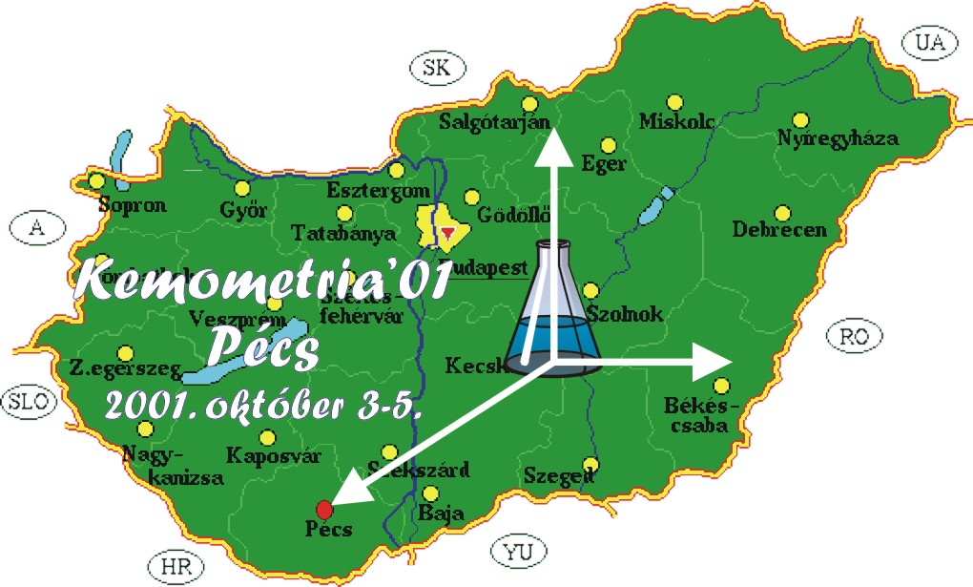
.

Hungarian Chemical Society
Chemometric Section
Hungarian Academy of Sciences
Automated Analysis and Chemometric
Working Group

