TITLE, 12 PT, TIMES NEW ROMAN, CAPITAL (EXCEPT FORMULAS), BOLD, MIDDLE ALIGNED TEXT, AFTER ONE EMPTY ROW, 12 PT, SINGLE-SPACE LINE, NO SPACE

Authorª, Lecturer underlined^{b}, after empty row 11pt^{c} Times New Roman

ª Full name and corresponding address of workplace/department 10 pt, italics, middle aligned
^{b} Full name and corresponding address of workplace/department, 10 pt, italics, middle aligned
After the last one, one empty row,10 pt

Edges: Up and down 3 cm, left and right 2,5 cm (gutter: 0 cm) Normal style: 11 pt, justified, 1.5-line space, 1,0 cm indent from the left in the first line, interval space between paragraphs 0 pt. Citations should be given in square brackets [1]. Among citations in order dash [1-3], among citations not in order comma [1,3] should be given.

Length of abstract for the conference proceedings should be 5-7 pages in English.

Figures and tables should be placed in the text, middle-aligned, with 1-1 empty row before and after the main text. Title of the figures should be placed under the figure, 10 pt, middle aligned.
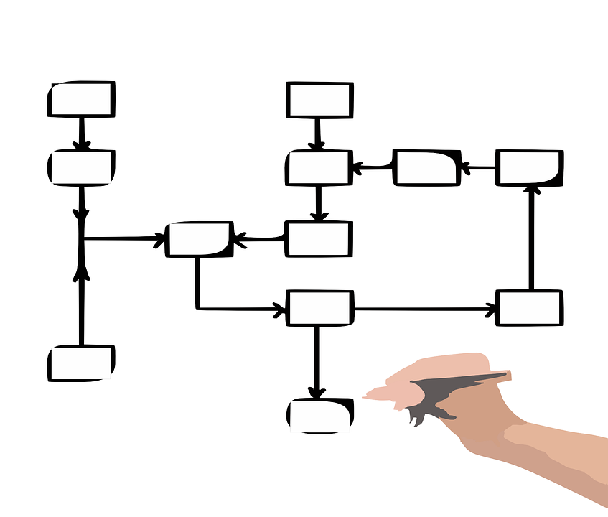
1. Figure. Right format of figure’s subtitling

In case of tables, title should be placed above the table, middle-aligned, 10 pt

1. Table. Right format of table’s subtitling
one | zero | zero
1 | 0 | 0

Citations should be given in the very end of the abstract. Number of them in square brackets, without indent, than with 0,75 cm indent full names of the authors in the following format:

[1] X. Surname, Y. Z. Surname2; Full name of the journal, year (volume) first page-last page.
[2] Editor of book: G. Kiss, Authors of chapter: E. Writer, A. Co-writer; Title of the book; Title of the citated chapter, 1977 578-580.
[3] H. W. Kroto, J. R. Heath, S. C. O'Brien, R. F. Curl, R. E. Smalley, Nature, 1985 (318) 162-163.

Acknowledgement follwing the citations after 2 empty rows, 10 pt, Times New Roman, bold, no indent

